# Real-Time River Water Quality Monitoring and Control System

**A PROJECT REPORT**

***Submitted by***

# Vishnu kumar N (Roll No: 822719104054)

**Mathan kumar T (Roll No: 822719104031)**

# Sasikumar K (Roll No: 822719104043)

**Suresh S (Roll No:822719104051)**

***in partial fulfillment for the award of the degree of***

# BACHELOR OF ENGINEERING IN

**DEPARTMENT OF COMPUTER SCIENCE AND ENGINEERING**

Government College OF Engineering Sengipatti, Thanjavur 613402

***TABLE OF CONTENTS***

# TABLE OF CONTENTS

|  |  |  |
| --- | --- | --- |
| **CHAPTER NO.** | **TITLE** | **PAGE**  **NO.** |
|  | **ABSTRACT** | **5** |
| **1** | **INTRODUCTION** | **6** |
|  | 1.1 PROJECT OVERVIEW | **6** |
|  | 1.2 PURPOSE | **6** |
| **2** | **LITERATURE SURVEY** | **8** |
|  | 2.1 EXISTING PROBLEM | **8** |
|  | 2.2 REFERENCES | **8** |
|  | 2.3 PROBLEM STATEMENT DEFINITION | **10** |
| **3** | **IDEATION & PROPOSED SOLUTION** | **12** |
|  | 3.1 EMPATHY MAP CANVAS | **12** |
|  | 3.2 IDEATION & BRAINSTROMING | **13** |
|  | 3.3 PROPOSED SOLUTION | **15** |

|  |  |  |
| --- | --- | --- |
|  | 3.4 PROBLEM SOLUTION FIT | **17** |
| **4** | **REQUIREMENT ANALYSIS** | **18** |
|  | 4.1 FUNCTIONAL REQUIREMENT | **18** |
|  | 4.2 NON - FUNCTIONAL REQUIREMENT | **18** |
| **5** | **PROJECT DESIGN** | **20** |
|  | 5.1 DATA FLOW DIAGRAMS | **20** |
|  | 5.2 SOLUTION & TECHNICAL ARCHITECTURE | **21** |
|  | 5.3 USER STORIES | **22** |
| **6** | **PROJECT PLANNING & SCHEDULING** | **235** |
|  | 6.1 SPRINT PLANNING & ESTIMATION | **25** |
|  | 6.2 SPRINT DELIVERY SCHEDULE | **27** |
| **7** | **CODING & SOLUTIONING** | **32** |
|  | 7.1 DEVELOP A WEB APPLICATION USING NODE- RED | **32** |
|  | 7.2 CONFIGURE THE MOBILE APPLICATION: | **33** |
|  | 7.3 CREATE AN HTTP REQUESTS TO COMMUNICATE WITH MOBILE APP | **34** |

|  |  |  |
| --- | --- | --- |
|  | 7.4 WEB DASHBOARD NODES FOR CREATE UI | **34** |
| **8** | **RESULTS** | **36** |
| **9** | **ADVANTAGES & DISADVANTAGES** | **39** |
|  | 9.1 ADVANTAGES | **39** |
|  | 9.2 DISADVANTAGES | **39** |
| **10** | **CONCLUSION** | **40** |
| **11** | **FUTURE SCOPE** | **41** |

***ABSTRACT***

# ABATRACT

Water pollution is one among the most important fears for the green globalization. In order to ensure the safe supply of the drinking water the quality needs to be monitor in real time. In this project we present a design and development of real time monitoring of the water quality in IOT (internet of things). Current water quality monitoring system is a manual system with a monotonous process and is very time-consuming. This paper proposes a sensor-based water quality monitoring system. The system consists of several sensors which is used to measure physical and chemical parameters of the water.

The main components of Wireless Sensor Network (WSN) include a microcontroller for processing the system, communication system for inter and intra node communication and several sensors. Real-time data access can be done by using remote monitoring and Internet of Things (IoT) technology. Data collected at the apart site can be displayed in a visual format on a server PC with the help of Spark streaming analysis through Spark MLlib, Deep learning neural network models, Belief Rule Based (BRB) system and is also compared with standard values. If the acquired value is above the threshold value automated warning SMS alert will be sent to the agent. The uniqueness of our proposed paper is to obtain the water monitoring system with high frequency, high mobility, and low powered. So our project will help to stop polluting the water

***INTRODUCTION***

# CHAPTER 1

## INTRODUCTION

* 1. **PROJECT OVERVIEW**

River Water quality monitoring System Water is one of the major compounds that profoundly influence ecosystem. But, nowadays it is been exploited heavily due to rapid industrialization, human waste and random use of pesticides and chemical fertilizers in agriculture, which leads to water contamination. Thus, a water monitoring system is necessary to observe the water quality in a large area such as lake, river, and aquaculture. As per the current world situation, Internet of Things (IoT) and remote sensing techniques are used in heterogeneous areas of research for supervising, congregate and analyzing data from the remote locations. In this paper, the suggested system is a minimal price real time water quality monitoring system in IoT environment. This system comprise of numerous sensors for assessing the physical and chemical parameter. The factors of water that can be assessed using these sensors are pH, turbidity, conductivity, dissolved oxygen. Using this system the real time quality of water bodies can be determined and the data uploaded over the Internet are analyzed.

## PURPOSE

Water quality refers to chemical, physical biological and radio logical characteristics of water. It is a measure of the condition of water relative to the necessities of one or more bio-tic species and or to any human need or purposes.

Water quality monitoring is defined as a sampling and analysis of the water in lake, stream, ocean and river and conditions of the water body. Smart water quality monitoring is a process of real-time monitoring and the analysis of water to identify changes in parameters based on the physical, chemical and biological characteristics.Monitoring water quality is clearly important: in our seas, our rivers, on the surface and in our ports, for both companies and the public.

It enables us to assess how they are changing, analyze trends and to inform plans and strategies that improve water quality and ensures that water meets its designated use.There are several indicators determining water quality. These include dissolved oxygen, turbidity, bio indicators, nitrates, pH scale and water temperature.Monitoring water quality helps to identify specific pollutants, a certain chemical, and the source of the pollution.There are many sources of water pollution: wastewater from sewage seeping into the water supply; agricultural

practices (e.g., the use of pesticides and fertilizer); oil pollution, river and marine dumping, port, shipping and industrial activity.

Monitoring water quality and a water quality assessment regularly provides a source of data identify immediate issues – and their source.

* Identifying trends, short and long-term, in water quality.
* Data collected over a period of time will show trends, for example identifying increasing concentrations of nitrogen pollution in a river or an inland waterway. The total data will then help to identify key water quality parameters.
* Environmental planning methods: water pollution prevention and management.
* Collecting, interpreting and using data is essential for the development of a sound and effective water quality strategy. The absence of real-time data will however hamper the development of strategies and limit the impact on pollution control. Using digital systems and programs for data collection and management is a solution to this challenge.
* Monitoring water quality is a global issue and concern: on land and at sea. Within the European Union, the European Green Deal sets out goals for restoring biological biodiversity and reducing water pollution, as well as publishing various directives to ensure standards of water quality. Individual nation states, for example France, have also clear regulatory frameworks requiring the effective monitoring of water quality. In the United States, the Environmental Protection Agency (EPA) enforces regulations to address water pollution in each state. Across the world, countries increasingly understand the importance of effective water quality monitoring parameters and methods.

***LITERATURE SURVEY***

# CHAPTER 2

**LITERATURE SURVEY**

The introduction about the literature survey gone through for the project are briefly discussed in this chapter.

## EXISTING PROBLEM

Due to population growth, urbanization and climatic change

,competition for water resources is expected to increase, with a particular impact on agriculture, river water. Water will be suitableness to potable water monitoring compound spillage identification done rivers, remote estimation for swimming pools. It holds self-sufficient hubs that unite with the cloud to ongoing water control. The River water needed to be treated before it is used in agriculture feilds,hence the parameters affecting the quality of river-water need to be analysed and to be used for water treatement purpose

## REFERENCSES

1. **IoT Based Real-time River Water Quality Monitoring System**

This paper proposes a sensor-based water quality monitoring system. The main components of Wireless Sensor Network (WSN) include a microcontroller for processing the system, communication system for inter and intra node communication and several sensors. Real-time data access can be done by using remote monitoring and Internet of Things (IoT) technology.

1. **Review of Water Quality Monitoring using Internet of Things (IoT) Authors**: Mr. A. P. Roger Rozario, R. Surya

The quality of the water must be monitored in real-time to ensure its safety and supply. Monitoring water in traditional ways takes longer, which can take up to from 24 to 96 hours to identify contaminants in water supplies, which are more time taking. This project aims at developing a water quality monitoring system using sensors and IoT (Internet of Things). The water quality parameters like temperature, pH, and turbidity are measures using sensors and the water quality index is determined. The measured values from the sensors will be processed using a microcontroller, and alert message will be sent to the user via an android application developed using MIT app inventor in case of any abnormalities.

## A Development and Implementation of Water Quality Assessment Monitoring (WQAM) System using the Internet of Things (IoT) in Water Environment

**Authors**: Muhammad Farhan Johan, S. Abdullah, A. Zanal Saurabh S. Soman, Om Malik JEVA , 23 November 2021

This paper presents the development and implementation of Water Quality Assessment and Monitoring (WQAM) system. The system development used Wi- Fi enabled microcontroller to connect with the IoT environment and store the data in the IoT cloud server. The microcontroller used is Arduino UNO that interacts with three types of sensor probes which are pH, turbidity and temperature probe. All the data measurements is transferred using a Wi-Fi module which is ESP8266. The IoT cloud used to utilize the data frame is Thing Speak. This system was implemented on Bandar Pereda Lake and Deraa River in Pulao Pinang with two systems implemented at each location. The sensors were placed on the water surface for more accurate measurements. This system continuously measures the readings of pH, turbidity dan temperature on the lake/river for every 1 hour. Twenty readings were taken for every 1 hour within the first 20 minutes with 1 minute interval and the readings were stored in the IoT cloud server.

## IoT-based System for Real-time Water Pollution Monitoring of Rivers

The research proposes a system to remotely monitor the water quality of a river so that the authorities can gather better insights about the condition of that particular river and predict the critical future phenomena. Consequently, they will be able to take auspicious steps in order to protect the rivers and save the environment.

The proposed framework can observe the real-time value of pH, conductivity, turbidity, temperature and flow of the water by utilizing various sensors. Furthermore, through our device, effective predictions about imminent floods can be made. Thus, authorities can commence early warning for floods and ensure prompt evacuation. Thus, our technique can significantly minimize the casualties caused by this disaster. In this context, real-time feeds are obtained through Internet of Things (IoT). For wireless data transmission Message Queuing Telemetry Transport (MQTT) is used.

## Design and Implementation of Real Time Approach for The Monitoring of Water Quality Parameters

Access to safe drinking water is essential to nurturing human life on earth. Polluted air and unsanitary water can cause health problems. Unhygienic water can cause stomach and healthrelated problems.

A specific range of water quality parameters, mainly temperature, pH, total dissolved solids (TDS) and turbidity, can degrade the growth of this bacteria. This presented paperwork is to develop a smart water quality monitoring system using four sensors and an IoT platform to help determine water quality. It is to analyse the parameters of water samples such as tap water, co way water, river water, pond water, and lake water whether these water samples are in the threshold range for drinking or not. The device is initially used to measure pH, turbidity, total dissolved solids (TDS) and temperature, and then sent the information to the microcontroller Arduino Uno.

## An IoT Based Smart Water Quality Monitoring System using Cloud

Other sources of pollution include agricultural runoff and unregulated small scale industry that results in polluting, most of the rivers, lakes and surface water in India. In this paper, An IoT Based Smart Water Quality Monitoring System using Cloud and Deep Learning is proposed to monitor the quality of the water in water- bodies. In conventional systems, the monitoring process involves the manual collection of sample water from various regions, followed by laboratory testing and analysis. This process is ineffective, as this process is arduous and timeconsuming and it does not provide real-time results. The quality of water should be monitored continuously, to ensure the safe supply of water from any water bodies and water resources. Hence, the design and development of a low- cost system for real-time monitoring of water quality using the Internet of Things (IoT) is essential. Monitoring water quality in water bodies using Internet of Things (IoT) helps in combating environmental issues and improving the health and living standards of all living things.

## Real-time water quality monitoring through Internet of Things and ANOVAbased analysis: a case study on river Krishna

Because the stochastic and intermittent property of wind speed, the prediction problem is very difficult to solve. The prediction method using BP neural network, wavelet BP neural network. The simulation results shows that the method used in this paper can give a better prediction, but there is still more other algorithm need to be studied to enhance the prediction precision.

## PROBLEM STATEMENT DEFINITION

The reduce the river water pollution and to monitor the parameters of river water and control measures can impact vegetation,health. The Real time analysis of Indicators of River water (Ph,salinity,nutrients,etc..,)

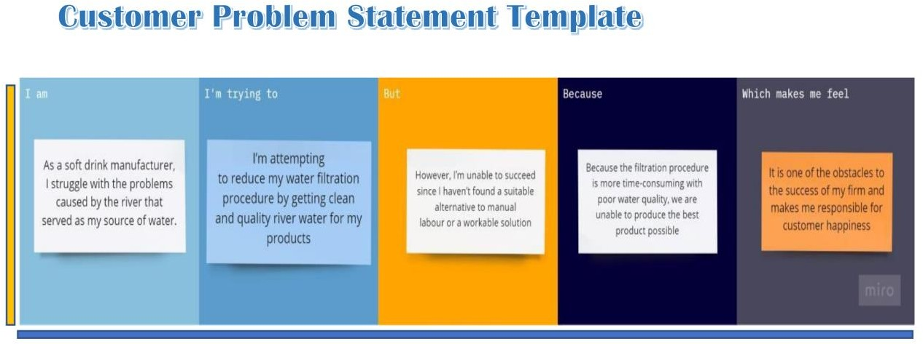

***IDEATION & PROPOSED SOLUTION***

# CHAPTER 3

**IDEATION & PROPOSED SOLUTION**

## EMPATHY MAP CANVAS

An empathy map is a simple, easy-to-digest visual that captures knowledge about a user’s behaviours and attitudes. It is a useful tool to helps teams better understand their users. Creating an effective solution requires understanding the true problem and the person who is experiencing it. The exercise of creating the map helps participants consider things from the user’s perspective along with his or her goals and challenges.

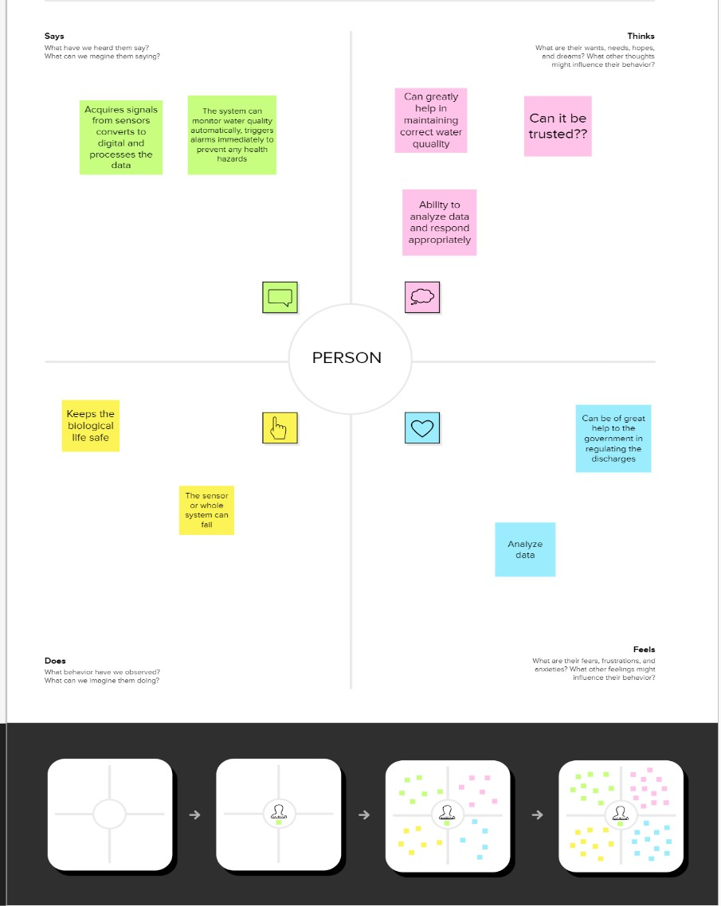

## IDEATION & BRAINSTORMING

Brainstorming provides a free and open environment that encourages everyone within a team to participate in the creative thinking process that leads to problem solving. Prioritizing volume over value, out-of-the-box ideas are welcome and built upon, and all participants are encouraged to collaborate, helping each other develop a rich amount of creative solutions.

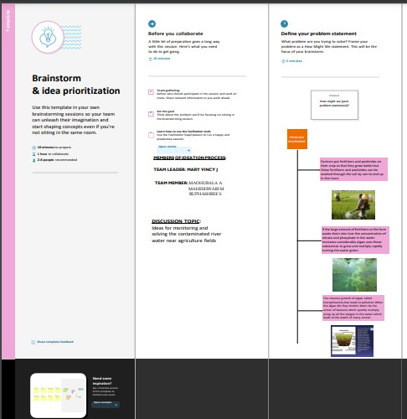

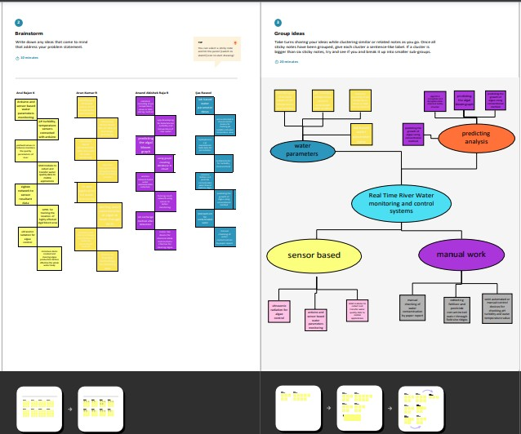

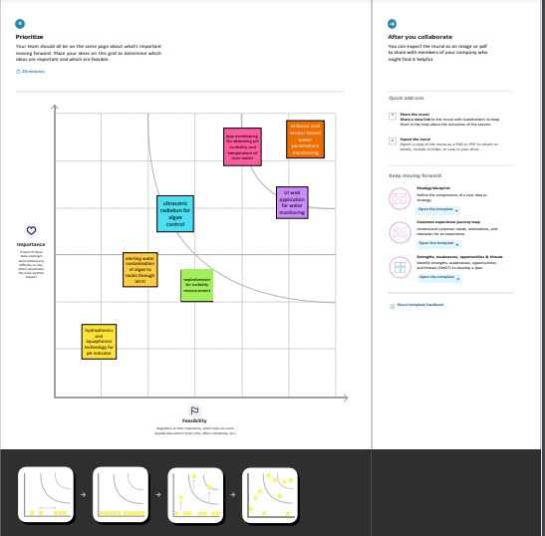

## PROPOSED SOLUTION

Project team shall fill the following information in proposed solution template.

|  |  |  |
| --- | --- | --- |
| **S.No.** | **Parameter** | **Description** |
| 1. | Problem Statement (Problem to be solved) | Massive growth of algae called eutrophication leads to pollution(monitoring and controlling the quality of river water) |

|  |  |  |
| --- | --- | --- |
| 2. | Idea / Solution description | Detecting the dust particles , PH level of water, Dissolved oxygen and temperature to be monitored and altering the authorities if water quality is not good. |
| 3. | Novelty / Uniqueness | River water quality can be monitored by web application. Quality parameter will track continuously with standard measurements. |
| 4. | Social Impact / Customer Satisfaction | Localities will not get suffered by poor quality of water by alerting them when the water quality is not good. |
| 5. | Business Model (Revenue Model) | Water quality monitoring system by aeron systems for industrial water treatment plant, river bodies, aqua forming ,digital loggers. |
| 6. | Scalability of the Solution | Measuring of real time values and continuous monitoring helps in maintaining the quality of water. |

* 1. **PROBLEM SOLUTION**

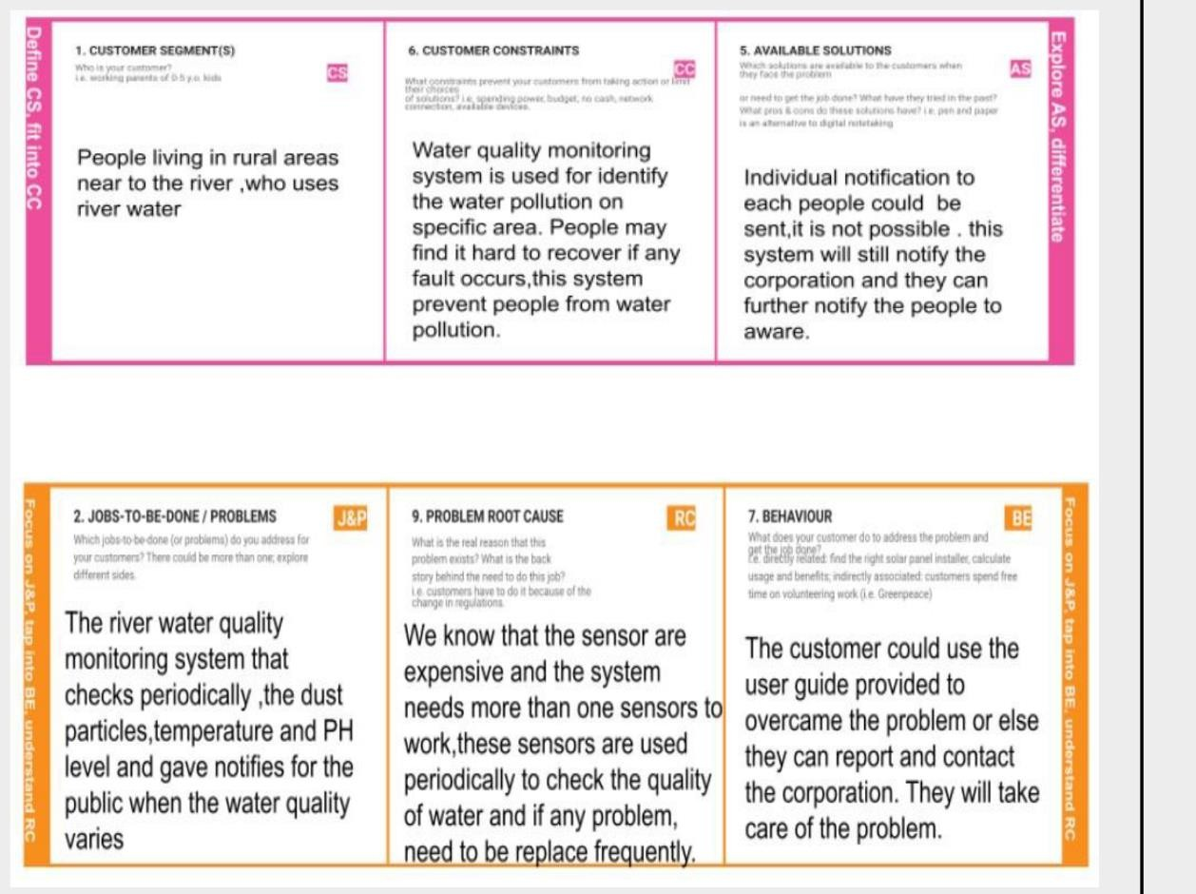

***REQUIREMENT ANALYSIS***

# CHAPTER 4 REQUIREMENT ANALYSIS

## 4.1 FUNTIONAL REQUIREMENT

Following are the functional requirements of the proposed solution.

|  |  |  |
| --- | --- | --- |
| **FR**  **No.** | **Functional Requirement (Epic)** | **Sub Requirement (Story / Sub-Task)** |
| FR-1 | User Registration | Registration through Form Registration through Gmail Registration through product mobile UI |
| FR-2 | User Confirmation | Confirmation via Email Confirmation via OTP |
| FR-3 | Ph level detection | Ph sensor is used to monitor the water quality and the signals are send to Arduino. |
| FR-4 | Turbidity detection | Turbidity sensor TS-300B measures the turbidity (counter of suspended matter) in the wash water and the signals are send to Arduino. |
| FR-5 | Ultrasonic generator | Waves generated at regular interval times to clear algae 25% ,50%, 100% |

**NON - Functional Requirements:**

|  |  |  |
| --- | --- | --- |
| **FR**  **No.** | **Non-Functional Requirement** | **Description** |

|  |  |  |
| --- | --- | --- |
| NFR-1 | Usability | Efficient to use and has simple monitoring system. |
| NFR-2 | Security | Mobile application is secured with firewalls protection |
| NFR-3 | Reliability | Real time sensor output values with future predicted data storage.98% efficient monitoring output . Assurance for aquaculture safety |
| NFR-4 | Performance | Greater performance and environmental safe model |
| NFR-5 | Availability | In form of mobile UI 24 x 7 monitoring system |
| NFR-6 | Scalability | Highly Scalable.It is capable to produce a best final output. |
| NFR-7 | Stability | It is highly stable |
| NFR-8 | Efficiency | It is highly efficient and it has simple monitoring system . |

***PROJECT DESIGN***

# CHAPTER 5 -PROJECT DESIGN

## DATA FLOW DIAGRAMS

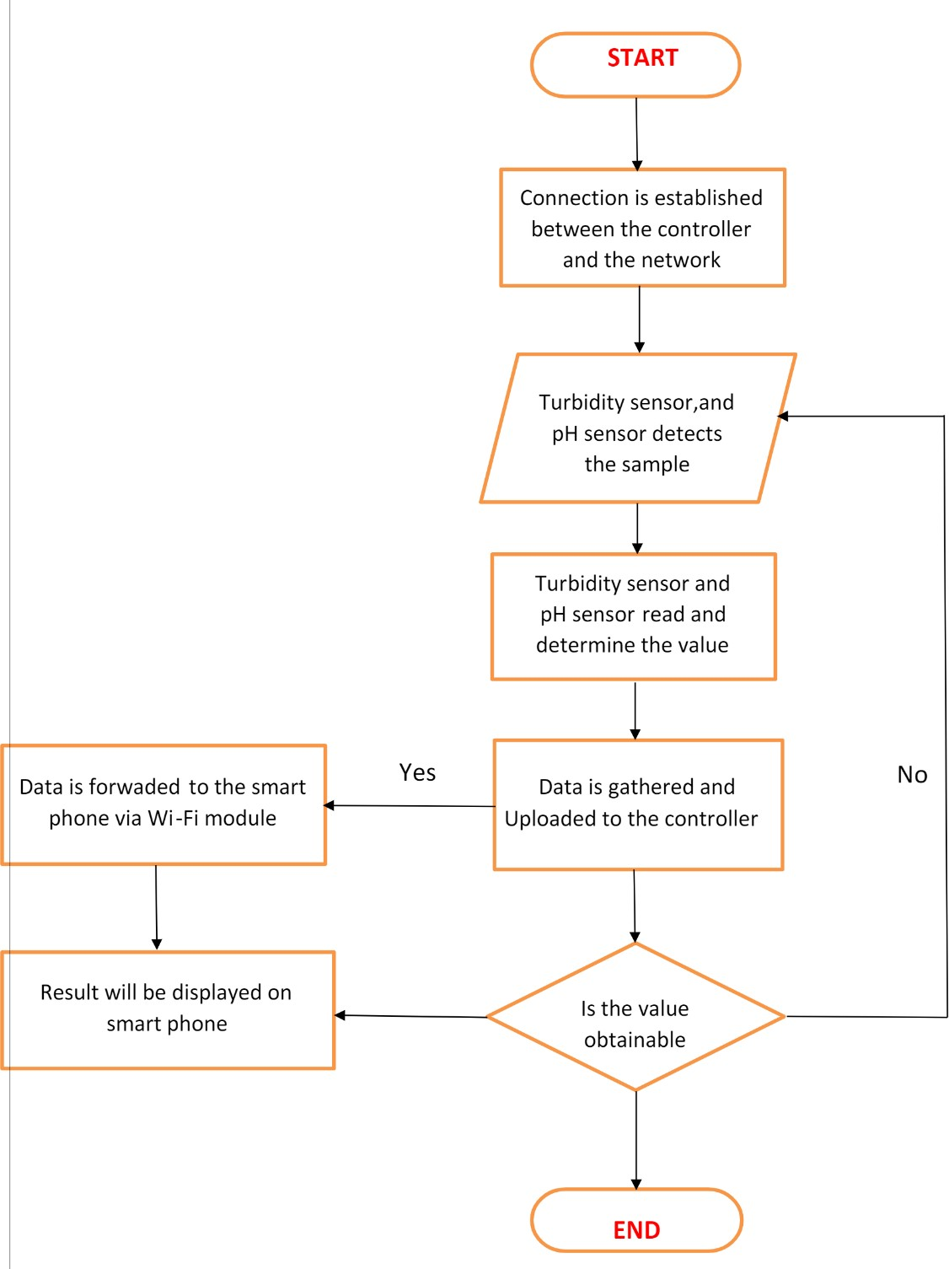

* 1. **SOLUTION & TECHNICAL ARCHITECTURE**

## SOLUTION ARCHITECTURE

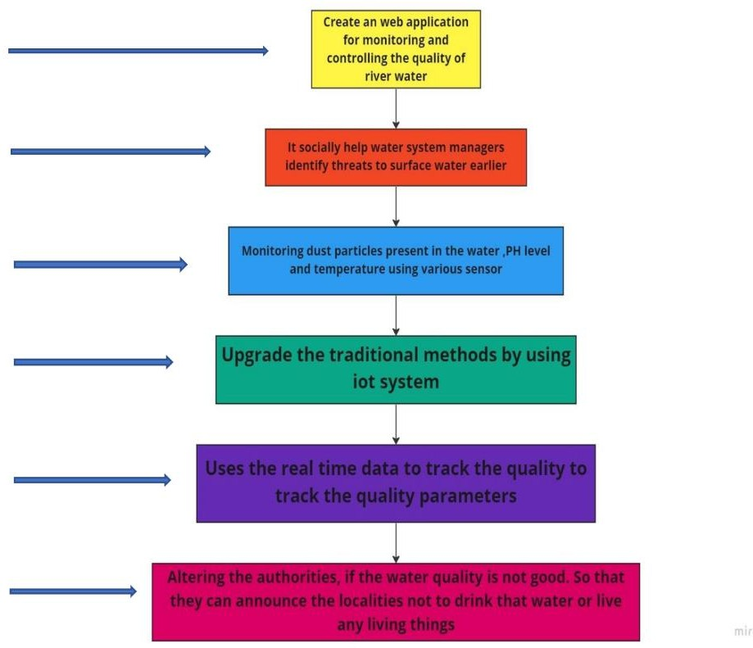

* + 1. **TECHNICAL ARCHITECTURE**

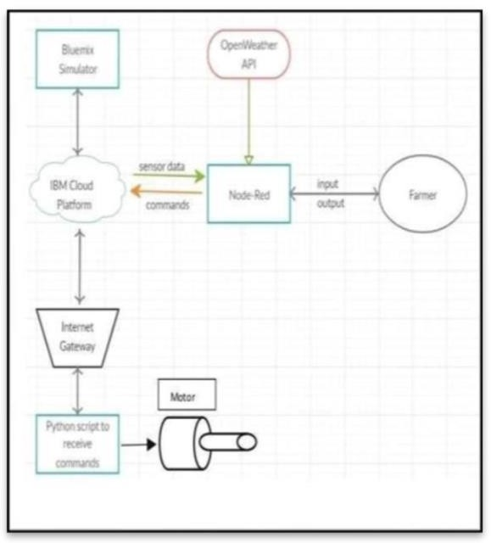

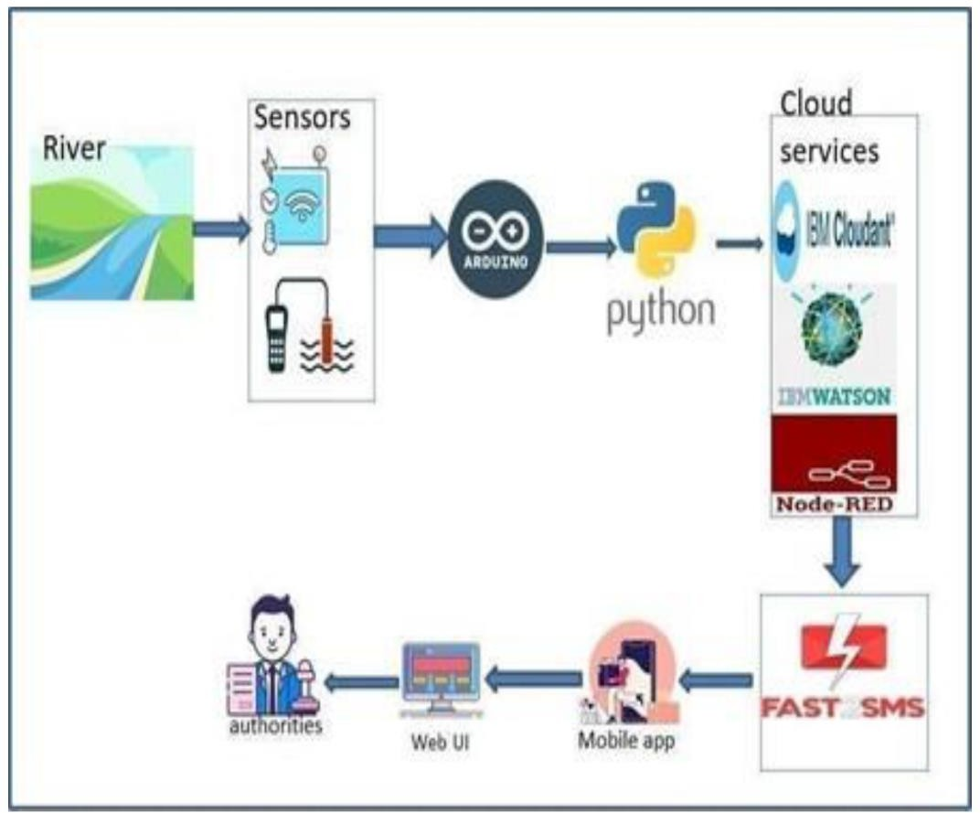

* 1. **USER STORIES :**

|  |  |  |  |  |  |  |
| --- | --- | --- | --- | --- | --- | --- |
| **User Type** | **Functional Requireme**  **nt (Epic)** | **User Story Numb**  **er** | **User Story**  **/ Task** | **Acceptance criteria** | **Priori ty** | **Relea se** |
| Custom | Registration | USN-1 | As a user, I can | I can | High | Sprint |
| er |  |  | register for the | access my |  | -1 |
| (Mobile |  |  | application by | account/da |  |  |
| user) |  |  | entering email, | shboard |  |  |
|  |  |  | password, and |  |  |  |
|  |  |  | confirming my |  |  |  |
|  |  |  | password. |  |  |  |
|  |  | USN-2 | As a user, I will receive a confirmation email once I have registered for the application | I can  receive e confirmatio n email & click confirm | High | Sprint-2 |

|  |  |  |  |  |  |  |
| --- | --- | --- | --- | --- | --- | --- |
|  |  |  |  |  |  |  |
|  |  | USN-3 | As a user, I can register for the application through Google | I can  register & access the dashboard with Google | High | Sprint  -1 |
|  |  | USN-4 | As a user, I can register for the application through Gmail | I can  register through the mail. | Mediu m | Sprint  -2 |
|  | Login | USN-5 | As a user, I can log into the  application by entering email, password & captcha | I can  receive login credentials. | High | Sprint  -1 |
|  | Interface | USN-6 | As a user, the interface should be user-friendly manner | I can able to access easily. | Mediu m | Sprint  -1 |
| Custom er (Web user) | dashboard | USN-7 | As a user, I can access the specific info(ph value, temp, humidity, quality). | I can able to know the quality of the water. | High | Sprint  -1 |
| Custom er (input) | View manner | USN-8 | As a user, I can view data in visual representation manner(graph) | I can easily understand by visuals. | High | Sprint  -1 |

|  |  |  |  |  |  |  |
| --- | --- | --- | --- | --- | --- | --- |
|  | Taste | USN-9 | As a user , I can able to view the quality(salty) of the water | I can easily know whether it is salty or not | High | Sprint  -1 |
|  | Color visibility | USN- 10 | As a user , I can able predict the water color | I can easily know the condition by color | High | Sprint  -1 |
| Administ rator | Risk tolerant | USN- 11 | An administrator who Is handling the system should update and take care of the application. | Admin should monitor the records properly. | Mediu m | Sprint  -2 |

***PROJECT PLANNING & SCHEDULING***

# CHAPTER 6

## PROJECT PLANNING & SCHEDULING

* 1. **SPRINT PLANNING & ESTIMATION**

|  |  |  |  |  |
| --- | --- | --- | --- | --- |
| **MILESTONE NAME** | **ACTIVITI**  **ES** | **MILESTO NE**  **NUMBER** | **DESCRIPTION** | **COMPLETI ON DATE** |
| **PREREQUISIT ES** |  |  | Create the IBM account and download the  necessary software  for your chosen category of the project | 19/11/2022 |
| **IDEATION PHASE** | Literature Survey | 1 | Literature survey on the selected  project by  gathering and referring  research paper and publications | 23/10/2022 |
|  | Empathy Map | 1 | Create an empathy map that list the user’s pains and gains | 23/10/2022 |
|  | Problem Statement | 1 | Summarize the problem that customer needs to be solved | 23/10/2022 |

|  |  |  |  |  |
| --- | --- | --- | --- | --- |
|  | Brainstorming | 1 | Gather many different ideas from the team mates and prioritize the idea  based on feasibility and innovative | 23/102022 |
| **PROJECT DESIGN PHASE**  **-1** | Proposed Solution | 2 | Prepare the proposed solution document that you proposed to solve the problem statement which should include | 23/10/2022 |
|  |  |  | feasibility |  |
|  |  |  | ,business model … etc. |  |
|  | Solution Architecture | 2 | Prepare Solution architecture diagram for the proposed solution | 23/10/2022 |
|  | Problem Solution Fit | 2 | Prepare Solution Fit Document for the proposed solution | 23/10/2022 |
| **PROJECT DESIGN PHASE**  **-2** | Customer Journey Map | 3 | Prepare a customer journey map to  understand how the  user interact and  experience your product | 23/10/2022 |
|  | Data Flow Diagram | 3 | Draw the data flow diagram for you proposed solution | 23/10/2022 |

|  |  |  |  |  |
| --- | --- | --- | --- | --- |
|  | Solution Requirements | 3 | Create a solution requirement document for the proposed solution | 23/10/2022 |
|  | Technology Stack | 3 | Prepare the technology stack diagram for the proposed solution | 23/10/2022 |
| **PROJECT PLANNING** | Milestone And Activity List | 4 | Create a document to show your milestones as well as activity in your development cycle | 25/10/2022 |
|  | Sprint Delivery Plan | 4 | Create a sprint plan for the project | 25/10/2022 |
| **PROJECT**  **DEVELOPMENT PHASE** | Sprint-1 | 5 | Delivery of the sprint-1 | 19/11/2022 |
|  | Sprint-2 | 6 | Delivery of the sprint-2 | 19/11/2022 |
|  | Sprint-3 | 7 | Delivery of the sprint-3 | 19/11/2022 |
|  | Sprint-4 | 8 | Delivery of the sprint-4 | 19/11/2022 |

* 1. **SPRINT DELIVERY SCHEDULE**

|  |  |  |  |  |  |  |
| --- | --- | --- | --- | --- | --- | --- |
| **SPRI NT** | **FUNCTIONAL REQUIREME**  **NT (EPIC)** | **USER STORY NUMB**  **ER** | **USER STORY / TASK** | **STORY POIN**  **TS** | **PRIORI TY** | **TEAM MEMBE**  **RS** |

|  |  |  |  |  |  |  |
| --- | --- | --- | --- | --- | --- | --- |
| Sprint-1 | Login | USN-1 | As a customer,  I might ensure login credential through gmail ease manner for the purpose of sending alert message to the parents or guardians (or) informing through normal message. | 2 | High | Madhubala A  Mary vincy J |

|  |  |  |  |  |  |  |
| --- | --- | --- | --- | --- | --- | --- |
| Sprint-1 | Registration | USN-2 | As a user,  I have to registered my details and tools details in a simple and easy manner by considering the safety of child, this registered system sends notification to the parents. | 2 | High | Maheswari M  Ruphashree S |
| Sprint-2 | Dashboard | USN-3 | As a user,  In case of any emergency situation parents(I) must get the alert notification and  location of the child. | 3 | Medium | Madhubala A  Maheswari M  Mary vincy J  Ruphashree S |

|  |  |  |  |  |  |  |
| --- | --- | --- | --- | --- | --- | --- |
| Sprint-3 | Dashboard | USN-4 | As a user,  I(parent) need to safeguard  child and  tracking the child’s location  and it is  important to notify  near police station incase of more emergency . | 2 | High | Madhubala A  Maheswari M |
| Sprint-3 | Dashboard | USN-5 | As a user,  Its good to have a IOT based  system to safeguard  monitoring without presence of parent. | 2 | High | Mary vincy J  Ruphashree S |

|  |  |  |  |  |  |  |
| --- | --- | --- | --- | --- | --- | --- |
| Sprint 4 | Monitoring the environment | USN 1 | User can monitor the situation of the environme nt from a dashboard that  displays  sensor information about the environme nt and child health. | 2 | High | Maheswari M  Mary vincy J |
| Sprint- 4 | Event Notification | USN 6 | Sending an alert SMS to the  parents and guardians in case of panic situation. | 2 | High | Madhubala A  Ruphashree S |

***CODING AND SOLUTIONING***

# CHAPTER 7- CODING AND SOLUTIONING

## BUILD MOBILE APP:

* 1. **DEVELOP A WEB APPLICATION USING NODE- RED**
     1. Double-click the tab with the flow name, and call it Earthquake Details
     2. Click the hamburger menu, and then click Manage palette. Look for node- red-node- open weather map to install these additional nodes in your palette.

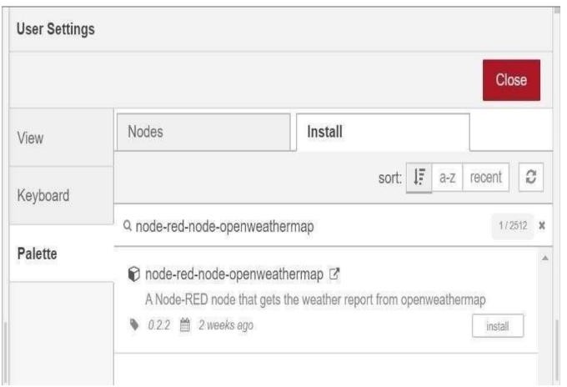

Add an HTTP input node to your flow.

Double-click the node to edit it. Set the method to GET and set the URL to

/earthquakeinfo-hr.

1. Add an HTTP response node, and connect it to the previously added HTTP input node. All other nodes introduced in this sub-section is to be added between the HTTP input node and the HTTP response node.
2. Add an HTTP request node and set the URL to

https://earthquake.usgs.gov/earthquakes/feed/v1.0/summary /all_hour.geojson, the Method to GET and the Return to a parsed JSON object. This will allow extracting all earthquakes that occurred within the last hour. Name this node Get

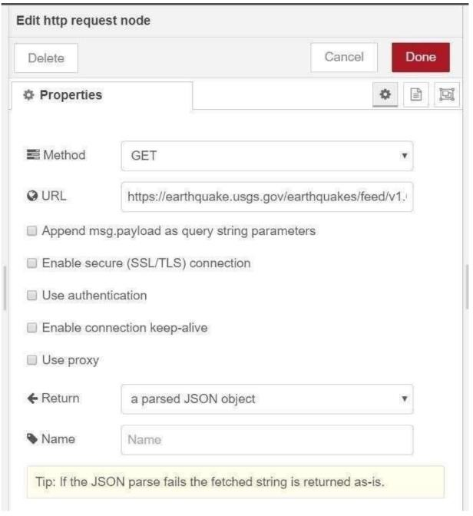

Add a change node. Double-click the node to modify it. Name this node Set Earthquake Info. In the Rules section, add rules to Delete msg.topic, msg.headers, msg. Status-code, and msg. response Url and msg.redirectList t and Set msg. payload features.

{

"type":properties.type, "magnitude": properties.mag, "location": properties.place,

"longitude":geometry.coordinates[0], "latitude":geometry.coordinates[1], "depth":geometry.coordinates[2], "timestamp": $fromMillis( properties.time)

}

## CONFIGURE THE MOBILE APPLICATION:

This is created through the use of gateway nodes to create a Virtual Data Warehouse. This Virtual Data Warehouse allows application developers to map access to remote data points. This software-defined gateway is run adjacent to the application it serves and can be deployed within a cloud environment or in a data center.

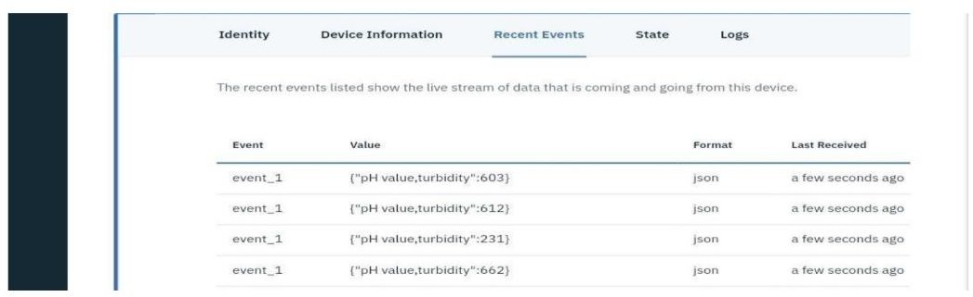

**WEB APPLICATION USING NODE RED:**

* 1. **CREATE AN HTTP REQUESTS TO COMMUNICATE WITH MOBILE APP**

1. Ensuring that the browser communicates with the required server directly.
2. Ensuring that only the communicating systems have access to the messages they exchange.

HTTP transfers data in a hypertext format between the browser and the web server, whereas HTTPS transfers data in an encrypted format. As a result, HTTPS protects websites from having their information broadcast in a way that anyone eavesdropping on the network can easily see. During the transit between the browser and the web server, HTTPS protects the data from being accessed and altered by hackers. Even if the transmission is intercepted, hackers will be unable to use it because the message is encrypted.

* 1. Private Key: It is used for the decryption of the data that has been encrypted by the public key. It resides on the server-side and is controlled by the owner of the website. It is private in nature
  2. Public Key: It is public in nature and is accessible to all the users who communicate with the server. The private key is used for the decryption of the data that has been encrypted by the public key.

## WEB DASHBOARD NODES FOR CREATE UI:

If you design a proper and modern UI dashboard, it will give the users easy access to the information they need. For this to happen, the dashboard information needs to be easy-to-scan and contain only the key information. But, with many tools available, it can be hard to make the right choice or not exaggerate with the use of features. This is one of the many roles of a UX designer and as such, it demands knowing certain tricks to be handle d the right way.

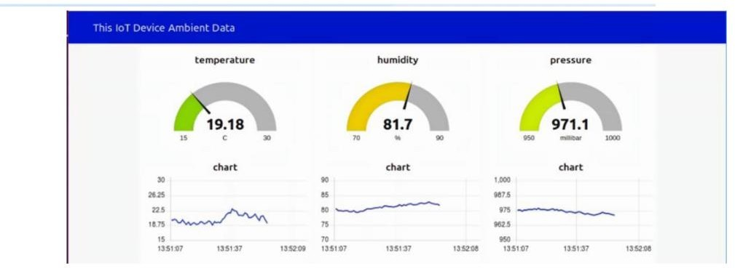

***RESULTS***

## WEB APP:

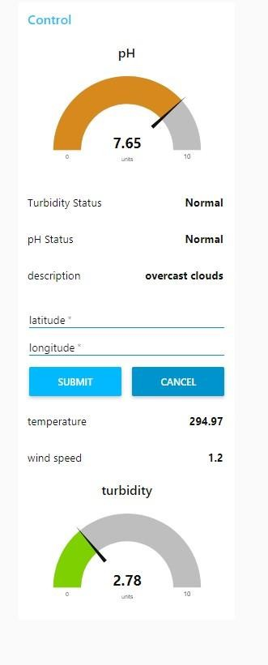

**MOBILE APP:**

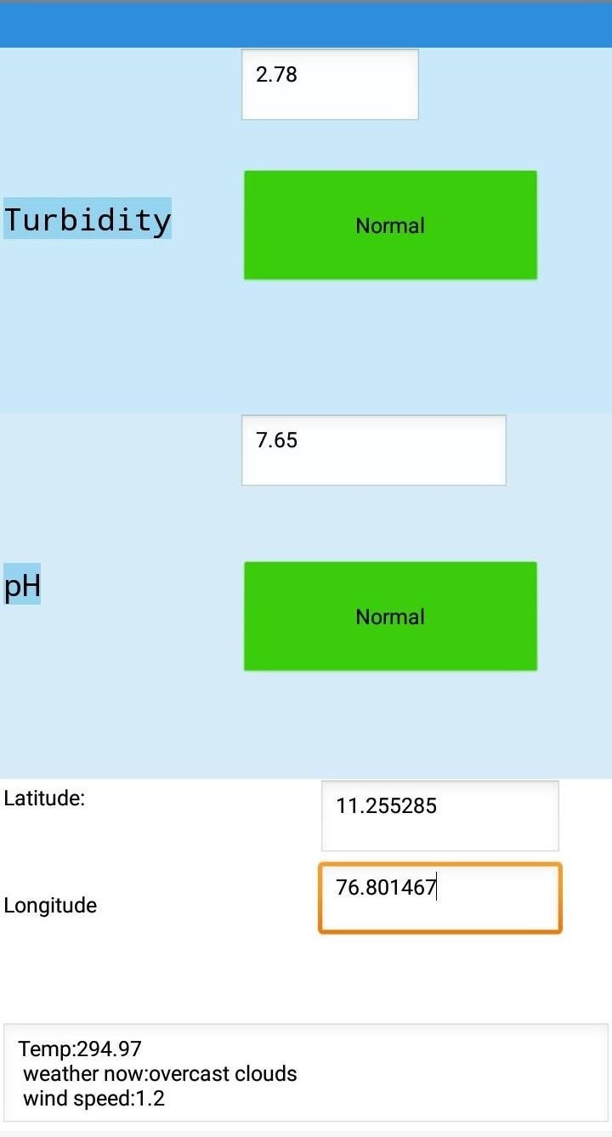

## NODE RED :

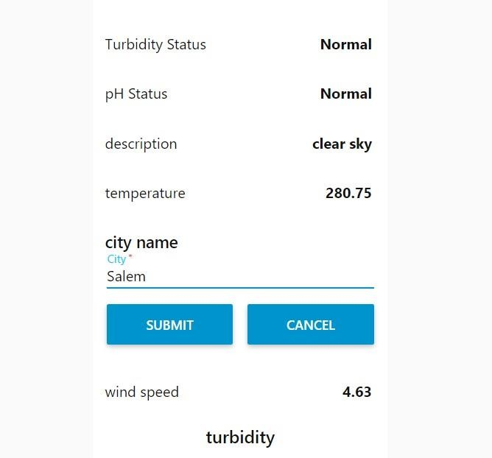

**MIT APP INVENTOR:**

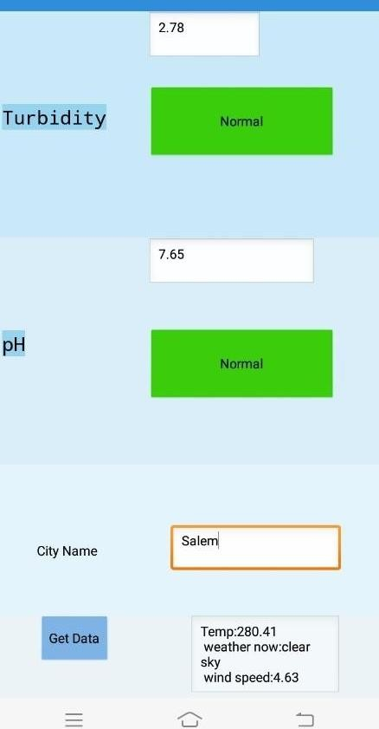

***ADVANTAGES AND DISADVANTAGES***

# CHAPTER 9

## ADVANTAGES :

* The prototype developed for water quality maintenance is very beneficial for safeguarding public health and also adds to the clean environment.
* The automation of the system makes the control and monitoring process more efficient and effective.
* Real time monitoring on mobile phone which is possible through the interface of plc with Arduino and Bluetooth module allows remote controlling of the system
* The automation of this water monitoring, cleaning and control process removes the need of manual labor and thus saves time and money.

## DISADVANTAGES :

* It is difficult to collect the water samples from all the area of the water body.
* The cost of analysis is very high.
* The lab testing and analysis takes some time and hence the lab results does not reflect real time water quality measurement due to delay in measurement.
* The process is time consuming due to slow process of manual data collection from different locations of the water body.
* The method is prone to human errors of various forms.

***CONCLUSION***

# CHAPTER 10

## CONCLUSION

Thus our project is used to Monitoring of Turbidity, PH & Temperature of Water makes use of water detection sensor with unique advantage and existing GSM network. The system can monitor water quality automatically, and it is low in cost and does not require people on duty.

So the water quality testing is likely to be more economical, convenient and fast. The system has good flexibility. Only by replacing the corresponding sensors and changing the relevant software programs, this system can be used to monitor other water quality parameters. The operation is simple.

It has widespread application and extension value.By keeping the embedded devices in the environment for monitoring enables self-protection (i.e., smart environment) to the environment. To implement this need to deploy the sensor devices in the environment for collecting the data and analysis. By deploying sensor devices in the environment, we can bring the environment into real life i.e. it can interact with other objects through the network. Then the collected data and analysis results will be available to the end user through the Wi-Fi.

***FUTURE SCOPE***

# CHAPTER 11

## FUTURE SCOPE

We use water detection sensor has unique advantage. It consumes less time to monitor than a manual method for checking polluted levels, and notifies immediately to reduce affected rate of pollution in water.

People who are living in rural areas near to the river will be very satisfied with our idea. It will be useful to monitor water pollution in specific area. So this system prevent people from water pollution.

It will be used for farming purpose to check quality water, temperature and PH level. Our Impact of this project is also create a social satisfaction for farmers too. The scalabilty of this project gives the addition of more different type of sensors. By interfacing the relay we can control the supply of water. We can also implement as a revenue model. This system could also be implemented in various industrial processes. The system can be modified according to the needs of the user and can be implemented along with lab view to monitor data on computers.